# PyCity Schools Analysis and Takeaways

Background

PyCity is a fictional city located somewhere in the world. The City is rather large and contains 15 high schools. The City requires its schools to disclose annual test outcomes on standardized reading and math tests administered to each high school student.

Data Cleaning Methodology

This data was relatively clean and didn’t contain any null values. The data was sorted and filtered in several ways including, but not limited to:

* Calculation of average test scores and pass/fail rates
* Calculation of spending per student
* Sorting by school size, school type, grade, and spending per student

Key Takeaways

**Charter schools seem to be more efficient with their dollars.** While charter schools spend less per student ($599.50 per student vs the District school average of $643.57 per student), their educational outcomes are much higher than their District counterparts. For example, the average percentage of students who passed their math exams was 93.6% for the charter schools, compared to 66.6% for District schools. This disparity in outcomes could be due to the fact that charter schools are often subject to fewer restrictions regarding pay structures and budget allocation.

**Test Scores by School Type**

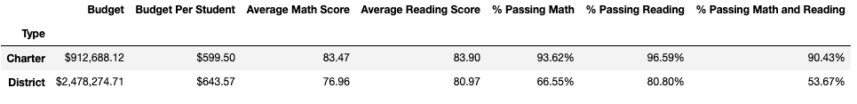

**Small to medium sized schools are correlated with better performance.** Small and medium schools have average student success rates in the 90’s, compared to the large schools whose average student success rate in both math and reading was 56.6%. This difference in performance could be related to the lower student to teacher ratio that small to medium schools can often offer. A lower ratio of students to teachers means that students have more opportunities for individual attention and tutoring.

**Test Scores by School Size**

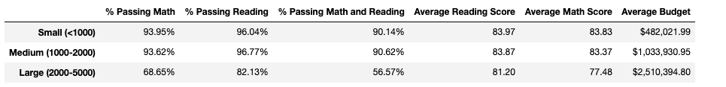

**Spending more doesn’t guarantee performance.** Just because a school spends more per student, doesn’t mean that educational outcomes are higher. Schools that spent $631-$660 per student saw average success rates that were anywhere from 12 – 31 percentage points lower than their counterparts that spent $591-$610 per student. This lack of correlation makes sense since spending more doesn’t equate spending more dollars on student instruction or other areas directly tied to student success.

**Test Scores by Average Per Student Spending ($)**

Limitations and Alternative Analysis

**Incomplete Context** – educational outcomes rely on school instructional policies and spending, but they also are often correlated with exogenous factors like whether or not a student has proper nutrition. Many of these factors are ultimately tied to socioeconomic status, so it would have been helpful to have data about the median household income within the high school’s zoning area, or the percentage of students at the school that participate in the free and reduced lunch program.